DSA LAB – 4

TASK 1) Code:

Output:

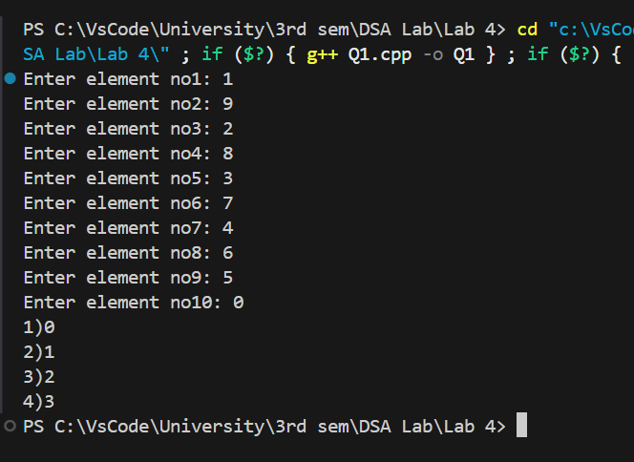

TASK 2) Code:

Output:

TASK 3) Code:

Output:

TASK 4) Code:

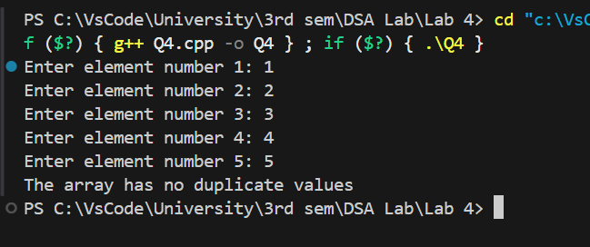Output:

TASK 5) Code:

Output:

Task 6) Code:

Output:

